}

**Guía1. Definición Proyecto APT**

**Asignatura Capstone**

1. **PARTE I**

|  |
| --- |
| **1. Antecedentes Personales** |
| A continuación, se presenta una tabla en la que debes completar la información solicitada. |

|  |  |
| --- | --- |
| Nombre estudiante | **Víctor Cáceres, Felipe Valenzuela, Joaquín Velis** |
| Rut | **19.994.508-4 , 20.690.939-0 , 29.062.419-K** |
| Carrera | **Ingeniería en Informática** |
| Sede | **Maipú** |

|  |
| --- |
| **2. Descripción Proyecto APT** |
| En la descripción debes señalar brevemente el nombre de tu proyecto APT y las competencias del perfil de egreso que vas a poner en práctica. Si en tu carrera están definidas las áreas de desempeño, también menciona a qué áreas de desempeño está vinculado el proyecto. |

|  |  |
| --- | --- |
| Nombre del proyecto | **Proyecto Rodado** |
| Área (s) de desempeño(s) | ***Software Development***  ***Database Management***  ***User Experience (UI/UX)*** |
| Competencias | ***Programming***  ***Project Management***  ***Data Query***  ***Implementation and Systemic Solutions*** |

|  |
| --- |
| **3. Fundamentación Proyecto APT** |
| A continuación, se presentan distintos campos que debes completar con la información solicitada. Esta sección busca que describas en detalle tu proyecto y justifiquen su relevancia y pertinencia. |

|  |  |
| --- | --- |
| Relevancia del proyecto APT | Our project primarily aims to solve and bring efficiency and effectiveness to a project currently in place at Mall Arauco Maipú. The tasks carried out by workers in the support area are very slow and follow tedious processes. We will automate the entire process they perform, helping them save significant time and ensuring a pleasant experience for the people who approach them for assistance.  We chose this topic mainly because one of our team members works in that area and is familiar with the situation and how it is managed. A significant improvement is needed to save time and reduce complaints, which would benefit him, his colleagues on the same shifts, and the entire mall. |
| Descripción del Proyecto APT | With this project, we aim to automate a task carried out at Arauco Maipú. This involves creating an app to register users and query user data in a database, as well as modifying the data provided by the customers. The customers primarily request accessories at the mall and later return them. Automation is needed for the entire process, which includes registering new users, recalling them in the existing database, logging the returns, and capturing the customers' signatures. |
| Pertinencia del proyecto con el perfil de egreso | It is 100% related because we are implementing an IT solution for a group or entity that needs it, and we contribute with our knowledge, offering various options. All of this involves requirements gathering, decision-making, solution implementation, and goes through the entire project management process, as well as, of course, development and programming, which is the most important aspect. |
| Relación con los intereses profesionales | This type of project is fully aligned with our interests because the group's main interests are Programming and Project Management. These complement each other perfectly since we need to fully program the application to be developed while also managing the project alongside the client. |
| Factibilidad de desarrollo del Proyecto APT | We believe that our project is feasible to develop, considering the various challenges along the way, and despite everything, it is possible. This is because we have approximately 10 weeks to fully develop the project, which is sufficient time. We do not require any external materials or resources, as what we are trying to automate and improve is an existing task that is currently poorly managed using Excel. We will utilize what we have at our disposal, such as free and reliable databases, and develop using programming languages that we are familiar with for both mobile and web.  A key advantage is that one of our team members has firsthand knowledge of how the work is done internally and knows exactly what is needed for our solution to be 100% effective and approved. We have ideas on how to improve the entire process.  We may face some challenges, such as the difficulty of testing the software in real time and on-site. Handling their actual database would be very challenging, so we will likely have to conduct testing with fictitious data. |

1. **PARTE II**

|  |
| --- |
| **4. Objetivos** |
| En este apartado debes definir objetivos generales y específicos del Proyecto APT. Es importante aclarar que los objetivos se deben plantear en forma clara, concisa y sin dar mayores explicaciones, es decir, deben entenderse por sí solos. Se sugiere redactarlos utilizando un verbo en infinitivo, pues ello obliga a precisar acciones concretas. |

|  |  |
| --- | --- |
| Objetivo general | The development of an application that improves efficiency and reduces waiting times in the support area will allow for the automation of the process of registering, querying, and managing accessory requests and returns at Mall Arauco Maipú. |
| Objetivos específicos | **Develop a User Registration Application: Create an interface that allows for the quick and efficient registration of new users and updating of existing user information.**  **Implement a Robust Database: Design and establish a database that securely stores, queries, and manages user and transaction data in an accessible manner.**  **Automate Request and Return Processes: Incorporate functionalities to register new accessory requests and manage returns, including the capture of digital signatures.**  **Optimize User Experience: Design an intuitive and user-friendly interface for both support staff and customers, improving efficiency and reducing waiting times.**  **Integrate with Existing Systems: Ensure that the application integrates properly with the mall's current processes and tools for a smooth transition.**  **Conduct Testing with Fictitious Data: Perform thorough testing using fictitious data to ensure the application functions correctly before implementation in a real environment.** |

|  |
| --- |
| **5. Metodología** |
| En el siguiente apartado deberás describir la metodología, propia de tu disciplina, que utilizarás para resolver el proyecto APT antes descrito, incluyendo las etapas y métodos de trabajo. |

|  |
| --- |
| Descripción de la Metodología |
| The chosen methodology for developing our project will be the **TRADITIONAL METHODOLOGY**. It follows a structured and sequential approach that facilitates project planning and execution. By dividing the development into clearly defined phases (such as requirements gathering, design, implementation, testing, and maintenance), it ensures that each step is fully completed before moving on to the next. This minimizes confusion and errors, which is ideal when requirements are stable and well-defined. Additionally, detailed documentation helps maintain process control and facilitates communication with stakeholders.  For the project of streamlining equipment lending, the traditional methodology is suitable because it provides a clear structure and a sequential process that ensures each phase of development is completed rigorously. By following a planned aproche, it is possible to define and stabilize all requirements from the start, minimizing the risk of unexpected changes and maintaining precise control over development. This guarantees that the lending system is built according to detailed specifications, resulting in a robust, well-documented product that meets the expectations established from the beginning. **Phase 1: Project Foundation (Weeks 1 to 4)****During the first four weeks, the project foundation phase will be carried out. In this stage, the project’s objectives and scope will be defined, along with forming the project team and assigning roles. A detailed project plan will be developed, establishing deadlines and the tools to be used. Initial meetings with stakeholders will be held to understand their needs and expectations, ensuring that all requirements are well-documented and approved, culminating in the formal establishment of the project.****Phase 2: System Development (Weeks 5 to 15)**This phase will cover from week 5 to week 15 and will include the design, development, and preliminary testing of the system. Development will be carried out in cycles, during which the system’s priority functionalities will be implemented. During these cycles, daily meetings will be held (if there are updates), with a primary focus on a weekly meeting (Monday) to assess progress, resolve impediments, and address and resolve questions throughout the process. Additionally, progress reviews for each team member will be conducted.In week 10, an interim project presentation will be made to showcase the progress achieved so far, to validate that the development aligns with user requirements. This will allow for any necessary adjustments before continuing with the remaining development.**Phase 3: Testing and Project Closure (Weeks 16 to 18)**The final phase of the project, from week 16 to week 18, will focus on thorough testing and project closure. During this stage, functionality, performance, and usability tests will be conducted to ensure that the system meets all defined requirements and is ready for use. End users will be involved in User Acceptance Testing (UAT) to ensure that the system is intuitive and functional.Once the system has passed all tests, the official launch of the lending system will proceed. Subsequently, a final project evaluation will be conducted, documenting lessons learned and recommending improvements for future developments. |

|  |
| --- |
| **6. Evidencias** |
| A continuación, describe qué evidencias serán evaluadas en el informe de avance y en el informe final de tu proyecto APT. Estas evidencias deben ser acordadas con tu docente. Se entenderá por evidencia los productos que se desarrollen durante el proyecto y cuyo propósito sea visibilizar o documentar cómo se ha implementado el trabajo. |

|  |  |  |  |
| --- | --- | --- | --- |
| **Tipo de evidencia** | **Nombre** | **Descripción** | **Justificación** |
| Final | Project Charter | Defines the project’s objectives, scope, participants, and assumptions. | Crucial for ensuring all stakeholders have a common understanding from the start. |
| Final | Project Management Plan | Details how key aspects of the project will be managed. | Essential for organized and controlled execution. |
| Final | Functional and Non-Functional Requirements | Specifies the functionalities the system must fulfill and non-functional requirements such as performance, security, and usability. | Ensures development aligns with client and end-user expectations. |
| Final | RACI Matrix | Responsibility matrix that defines the roles and responsibilities of the project team. | Facilitates communication and reduces confusion about who is responsible for each task. |
| Final | Schedule | Detailed calendar with activities, tasks, and project deadlines. | Allows for planning and monitoring progress. |
| Progress | User Interface Design | Sketches and detailed designs of system interfaces that will guide development. | Ensures interfaces are intuitive and meet established functional requirements. |
| Progress | Functional Prototypes | Preliminary versions of the system with key functionalities to be presented to stakeholders. | Facilitates stakeholder feedback and potential adjustments. |
| Progress | Project Status Report | Regular report on the project’s progress, presented weekly to keep stakeholders informed. | Vital for effective communication and timely decision-making. |
| Progress | Change Request | Documentation of any requests for modifications to the requirements or project scope. | Ensures that all changes are formally evaluated and approved before implementation. |
| Final | Source Code | Delivery of the code developed during the implementation phase. | Provides the necessary content for system review, testing, and maintenance. |
| Final | Code Repositories | Location of the source code in a version control system, accessible to the entire team. | Ensures source code management in a version control system. |
| Final | Test Plan | Defines the strategies and test cases to be performed to validate the system. | Ensures that all functionalities are adequately validated before release. |
| Final | Testing Test Cases | Detailed description of each test case designed to verify system functionalities and requirements. | Outlines specific test scenarios to ensure the system meets the requirements. |
| Final | Client Acceptance | Client's signature or approval indicating that the system meets the specified requirements and is accepted. | Validates the delivered project. |
| Final | Project Closure Documentation | Final documents summarizing the project, including results, lessons learned, and recommendations for the future. | Formally completes the project.y con |

|  |
| --- |
| **7. Plan de Trabajo** |
| En la siguiente tabla define la planificación de tu Proyecto APT de acuerdo a lo requerido. |

|  |  |  |  |  |  |  |
| --- | --- | --- | --- | --- | --- | --- |
| **Plan de trabajo proyecto ATP** | | | | | | |
| ***Competencia o unidades de competencias*** | ***Nombre de actividades/tareas*** | ***Descripción actividades/tareas*** | ***Recursos*** | ***Duración actividad*** | ***Responsable*** | ***Observaciones*** |
| **IT Project Management** | **Initial Meeting** | **Starts with a meeting to define the project.** | **Human resources, tools and technology, time, and planning.** | **2 days.** | **Víctor Cáceres**  **Felipe Valenzuela**  **Joaquín Velis** |  |
| **IT Solution Proposals** | **Requirements Gathering** | **Identify the documents needed throughout the project and understand how the current system for lending equipment works.** | **Human resources, tools and technology, documentation, infrastructure, and time.** | **5 days.** | **Felipe Valenzuela**  **Joaquín velis** |  |
| **Architectural Model** | **Technology Research** | **Choose the ideal programming language for the task.** | **Human resources, tools and technology, documentation, infrastructure, and time.** | **4 days.** | **Víctor Cáceres**  **Felipe Valenzuela** |  |
| **IT Solution Proposals and System Architectural Model** | **Functional and Technical Specifications** | **It will detail how the app will function and how it will be created in terms of technologies, architecture, etc.** | **Human resources, tools and technology, documentation, infrastructure, and time.** | **5 days.** | **Víctor Cáceres**  **Felipe Valenzuela**  **Joaquín Velis** |  |
| **System Architectural Model** | **Inicial design** | **A mock-up will be presented with the initial idea.** | **Human resources, tools and technology, documentation, infrastructure, and time.** | **4 days.** | **Víctor Cáceres**  **Felipe Valenzuela**  **Joaquín Velis** | **This is crucial, as it must be approved by the client.** |
| **Software Development** | **Interface Development** | **The user interface development will begin.** | **Human resources, tools and technology, documentation, infrastructure, and time.** | **12 days.** | **Felipe Valenzuela**  **Joaquín Velis** | **This may take time as the code might not work, we may get stuck when creating something, and not know how to develop it.** |
| **Software Development** | **Back-end Development** | **The internal workings of our app are developed, implementing the architecture and technologies chosen by the team.** | **Human resources, tools and technology, documentation, infrastructure, and time.** | **15 days.** | **Víctor Cáceres**  **Felipe Valenzuela**  **Joaquín Velis** | **This may take time as the code might not work, we might get stuck when creating something, and not know how to develop it.** |
| **Software Development** | **Front-end Development** | **Front-end Development** | **Human resources, tools and technology, documentation, infrastructure, and time.** | **10 days.** | **Víctor Cáceres**  **Felipe Valenzuela** | **This may not fit with the design that was presented, but it will be necessary to be very meticulous to develop it.** |
| **Product and Process Certification Testing** | **Code Testing and Adjustments** | **Once the development tasks are completed, testing begins, and the code is modified to improve functions.** | **Human resources, tools and technology, documentation, infrastructure, and time.** | **8 days.** | **Víctor Cáceres**  **Felipe Valenzuela**  **Joaquín Velis** | **Bugs may appear in the app.** |
| **Software Development** | **Development of Additional Features** | **We will have ample time in case the client wants to make any modifications or add more features; this will be the time to do so.** | **Human resources, tools and technology, documentation, infrastructure, and time.** | **5 days.** | **Víctor Cáceres**  **Felipe Valenzuela**  **Joaquín Velis** |  |
| **Product and Process Certification Testing** | **Internal Testing** | **Internal testing of the fully completed app begins.** | **Human resources, tools and technology, documentation, infrastructure, and time.** | **5 days.** | **Víctor Cáceres**  **Felipe Valenzuela**  **Joaquín Velis** |  |
| **Product and Process Certification Testing** | **Final Testing** | **Testing will be conducted with real clients at Arauco Maipú.** | **Human resources, tools and technology, documentation, infrastructure, and time.** | **4 days.** | **Víctor Cáceres**  **Felipe Valenzuela**  **Joaquín Velis** |  |
| **IT Project Management** | **Training and Documentation** | **Workers will be trained on how to use our app, and the final relevant documentation will also be completed.** | **Human resources, tools and technology, documentation, infrastructure, and time.** | **5 days.** | **Víctor Cáceres**  **Joaquín Velis** |  |
| **Implementation of Systemic Solutions** | **Launch** | **The app will be officially and fully launched.** | **Human resources, tools and technology, documentation, infrastructure, and time.** | **1 days.** | **Víctor Cáceres**  **Felipe Valenzuela**  **Joaquín Velis** |  |

|  |
| --- |
| **8. Carta Gantt** |
| Busca un formato de Carta Gantt que te acomode y organiza en este las actividades planificadas en el punto anterior considerando el periodo asignado para el desarrollo de tu Proyecto APT. Debes mantener la temporalidad del periodo académico en el desarrollo de las tres fases que contempla la Asignatura de Portafolio de Título. |

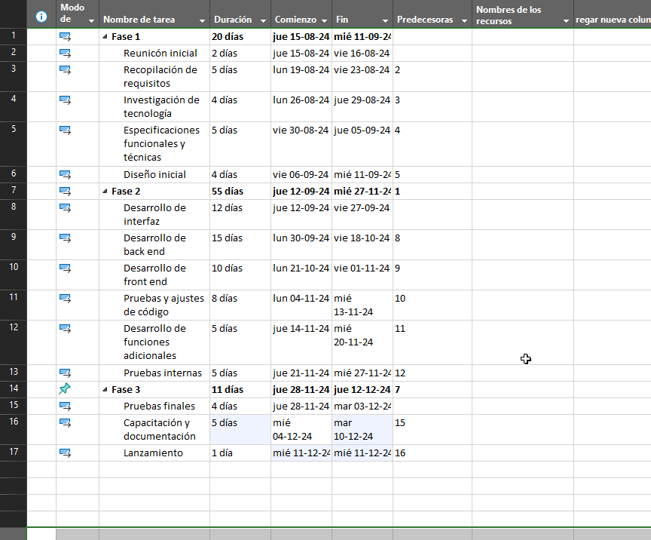

**9. Cronograma**

